**NATIONAL UNIVERSITY OF SCIENCES AND TECHNOLOGY**



**Fundamentals of Programming**

**LAB TASK (MANUAL 5)**

**Course Instructor:** Dr Khawaja Fahad Iqbal

**Lab Instructor:** Muhammad Affan

**Student Name:** Sayed Wasi Hyder Shah

**CMS ID:** 454424

**DATE:**

**26-10-2023**

**TASK 1**

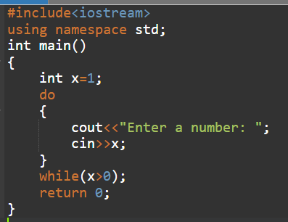

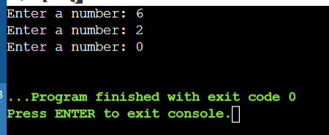

**TASK 2**

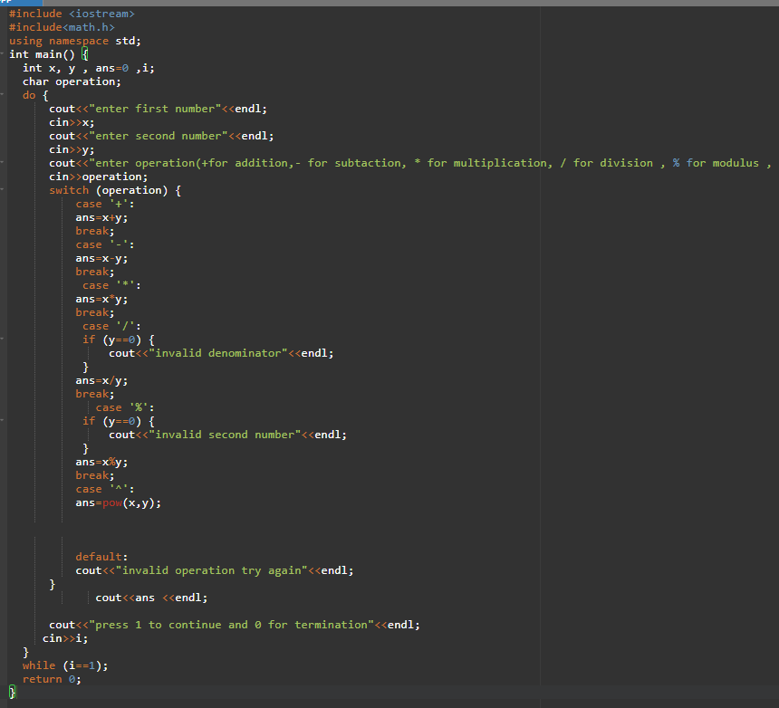

**TASK 3 (a)**

**TASK 3(b)**

**TASK 4(a)**

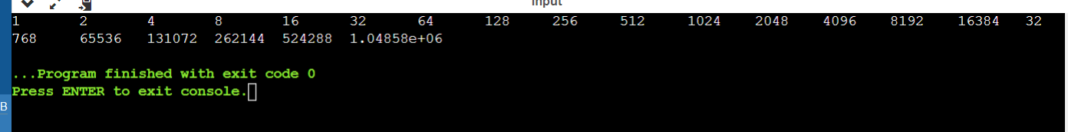

**TASK 4(b)**

